SCIENCE QTECH PROJECT SOLUTION:

CREATE DATABASE employee ;

USE EMPLOYEE;

SELECT EMP_ID, FIRST_NAME, LAST_NAME, GENDER, DEPT

FROM emp_record_table;

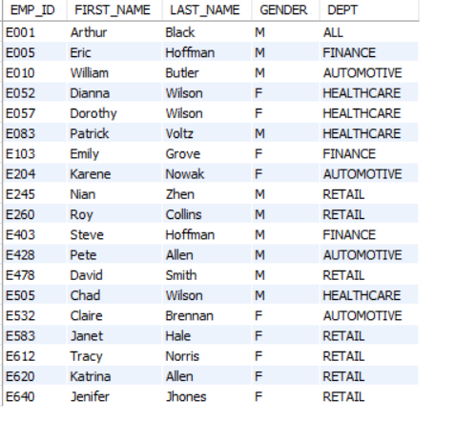

SELECT EMP_ID, FIRST_NAME, LAST_NAME, GENDER, DEPT,EMP_RATING

FROM emp_record_table

WHERE EMP_RATING <2 ;

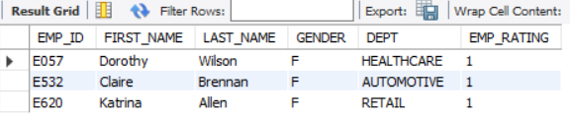

SELECT EMP_ID, FIRST_NAME, LAST_NAME, GENDER, DEPT,EMP_RATING

FROM emp_record_table

WHERE EMP_RATING > 4 ;

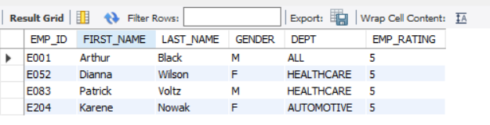

SELECT EMP_ID, FIRST_NAME, LAST_NAME, GENDER, DEPT,EMP_RATING

FROM emp_record_table

WHERE EMP_RATING BETWEEN 2 AND 4 ;

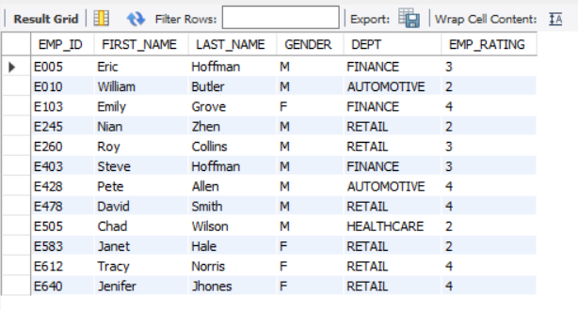

SELECT concat(FIRST_NAME,' ',LAST_NAME) AS NAME

FROM emp_record_table;

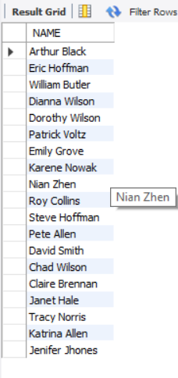

SELECT *

from emp_record_table WHERE (DEPT = 'healthcare')

UNION

SELECT *

from emp_record_table

WHERE (DEPT = 'finance');

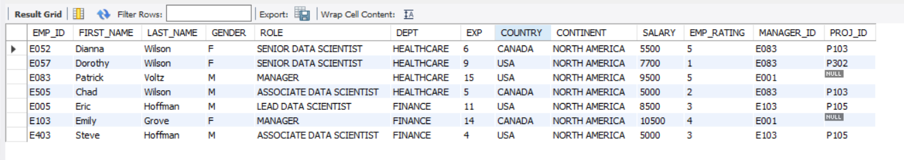

SELECT EMP_ID, FIRST_NAME, LAST_NAME, ROLE, DEPT, EMP_RATING,

MAX(EMP_RATING) OVER (PARTITION BY DEPT) AS MAX_RATING

FROM emp_record_table;

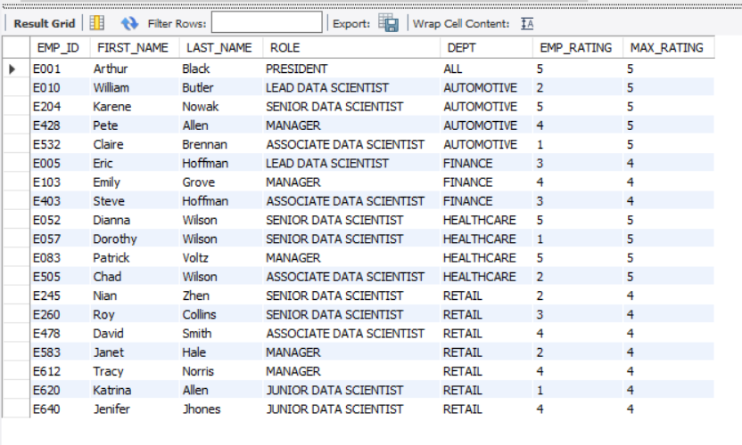

SELECT role, MIN(salary) AS min_salary, MAX(salary) AS max_salary

FROM emp_record_table GROUP BY role;

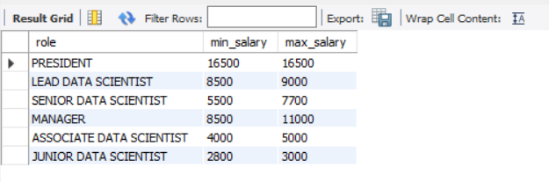

SELECT *,

DENSE_RANK() OVER (ORDER BY EXP DESC) AS rank_Exp

FROM emp_record_table;

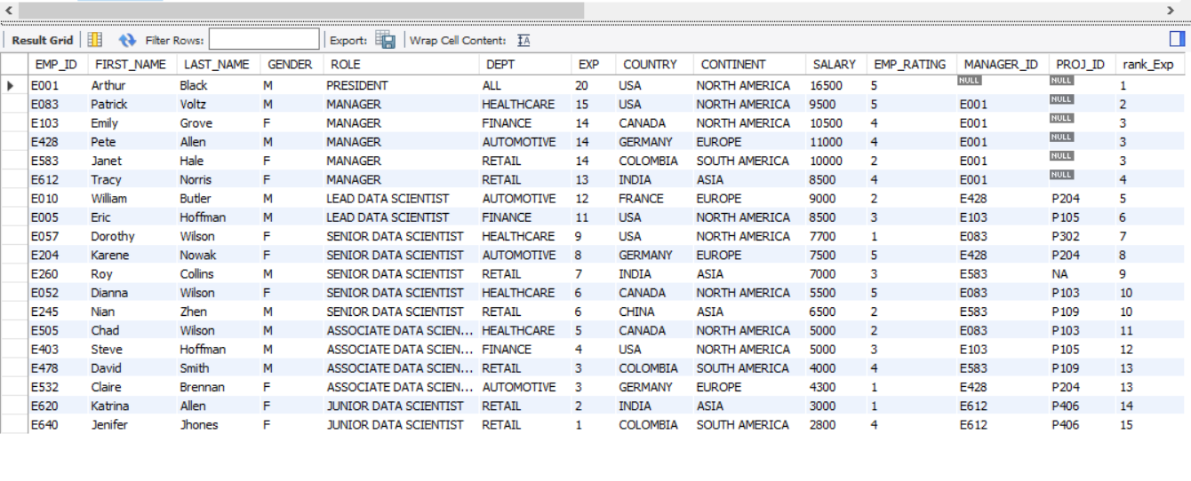

DROP VIEW empl_salary;

CREATE VIEW empl_salary AS SELECT EMP_ID, FIRST_NAME, LAST_NAME, SALARY, COUNTRY

FROM emp_record_table

WHERE SALARY > 6000;

SELECT EMP_ID, FIRST_NAME, LAST_NAME, EXP

FROM emp_record_table

WHERE (SELECT EXP > 10) ;

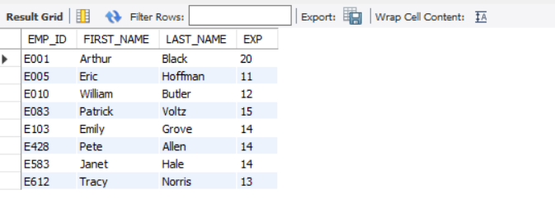

DROP PROCEDURE emp_exp_Three;

DELIMITER &&

CREATE PROCEDURE emp_exp_Three ()

BEGIN

SELECT * FROM emp_record_table WHERE EXP > 3 ;

END &&

CALL emp_exp_Three ();

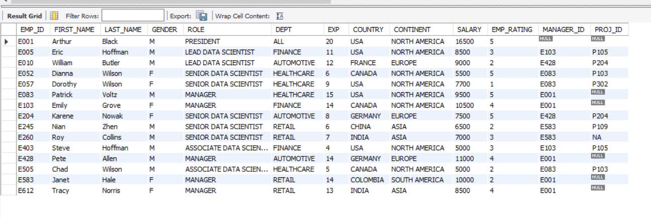

DROP FUNCTION emrol ;

DELIMITER //

CREATE FUNCTION emrol(EXP INT)

RETURNS VARCHAR(40)

DETERMINISTIC

BEGIN

DECLARE emp_role VARCHAR(40) ;

IF EXP BETWEEN 12 AND 16 THEN

SET emp_role = 'MANAGER' ;

ELSEIF EXP BETWEEN 10 AND 12 THEN

SET emp_role = 'LEAD_DATA_SCIENTIST';

ELSEIF EXP BETWEEN 5 AND 10 THEN

SET emp_role ='SENIOR_DATA_SCIENTIST';

ELSEIF EXP BETWEEN 2 AND 5 THEN

SET emp_role ='ASSOCIATE_DATA_SCIENTIST' ;

ELSEIF EXP<= 2 THEN

SET emp_role ='JUNOR_DATA_SCIENTIST';

END IF ;

RETURN (emp_role);

END //

SELECT EXP, emrol(EXP)

FROM data_science_team;

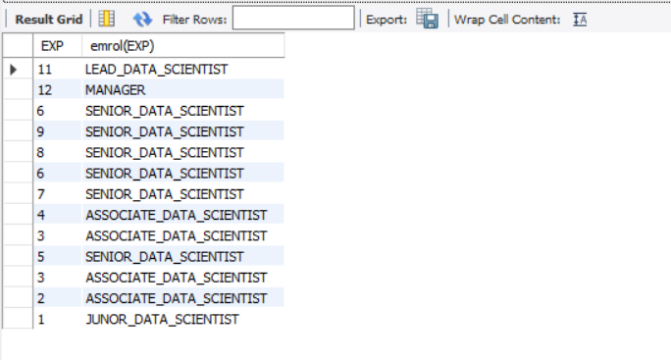

DROP INDEX indx ON emp_record_table;

CREATE INDEX indx ON emp_record_table (FIRST_NAME(40));

EXPLAIN SELECT EMP_ID, FIRST_NAME, LAST_NAME FROM emp_record_table WHERE

FIRST_NAME = 'ERIC';

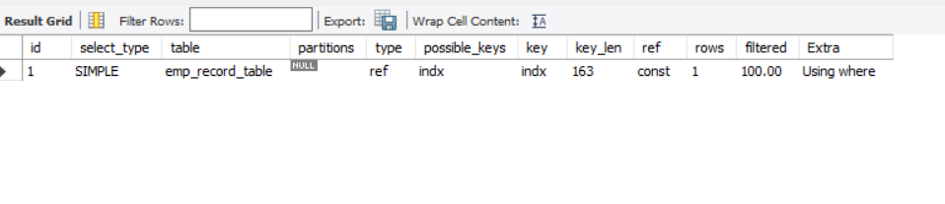

SELECT EMP_ID, FIRST_NAME, LAST_NAME, SALARY, EMP_RATING ,

(SALARY + SALARY*0.05* EMP_RATING) AS BONUS_SAL

FROM emp_record_table;

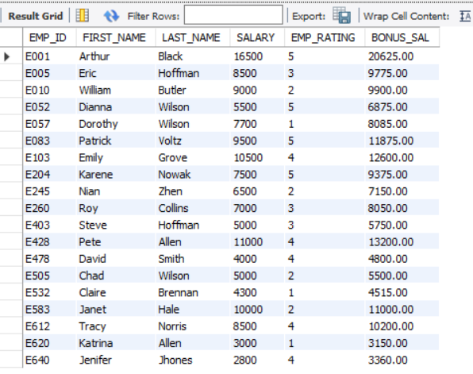

SELECT EMP_ID,FIRST_NAME,LAST_NAME,COUNTRY,CONTINENT,

AVG(SALARY) OVER (PARTITION BY COUNTRY) AS avg_sal_cntry ,

AVG(SALARY) OVER (PARTITION BY CONTINENT) AS avg_sal_cont,

COUNT(*) OVER (PARTITION BY COUNTRY) AS count_in_country ,

COUNT(*) OVER (PARTITION BY CONTINENT) AS count_in_continent

FROM emp_record_table;

